How to log in and complete the legal authorization (club president or DRFC):
Go to www.rotary.org/grants and click “My Rotary”. Then click Sign In/Register link to enter your username and password.

Hover over “Take Action” and under the Apply for Grants heading click “Grant Application Tool”.
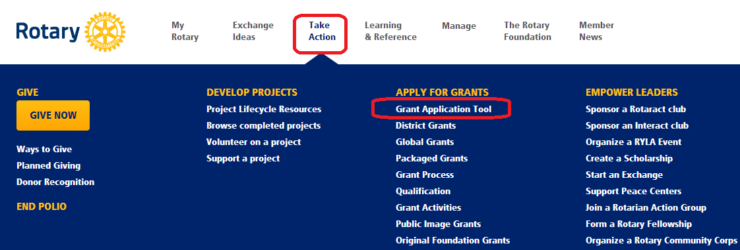
- Click “Global Grants” in the left-hand toolbar.
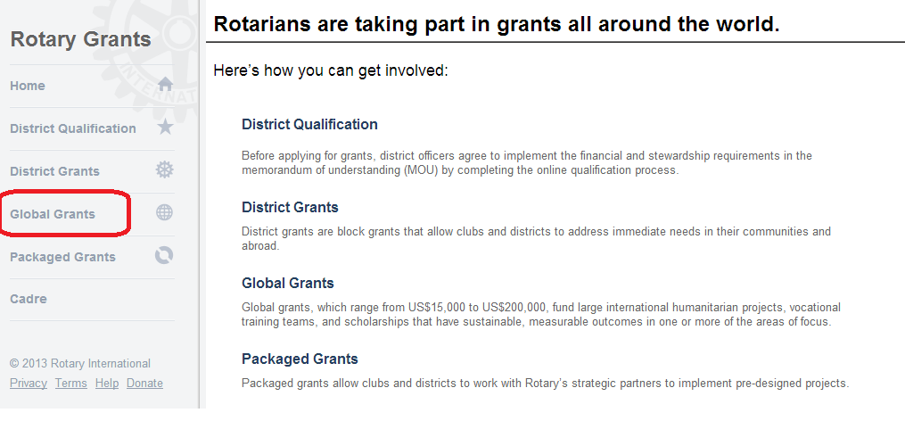

- Under the “Applications” heading find your grant number and click “Open”. Please note that if you access the grant under the “Attention Needed” heading you will be able to view the application but not provide the legal authorization.
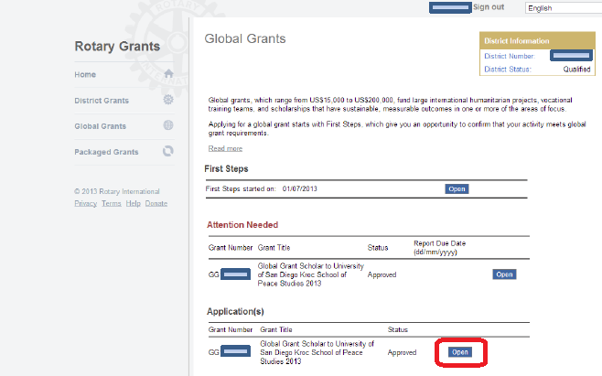

- Click the Legal Agreement tab to review the legal agreement. You will see your name listed below. To provide authorization, click the checkbox. A pop-up will appear confirming you have made the authorization and then a date will appear next to your name (see second screen shot).
Confirm to the primary contact that you have provided legal authorization.
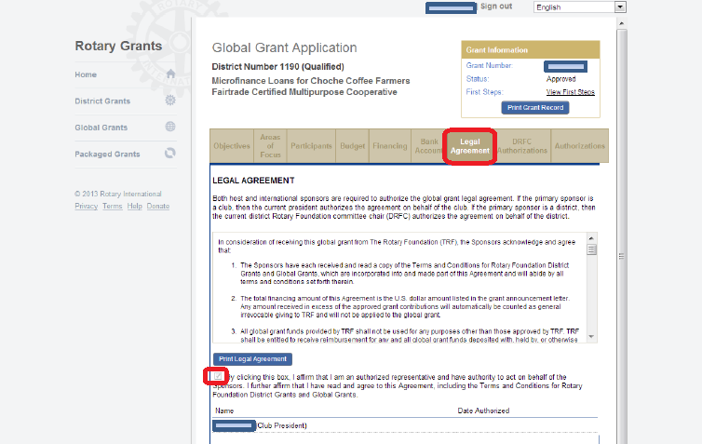

After you have authorized a date will appear next to your name.
